文本

**Breast Cancer**

**Mechanism and application of Brachytherapy in Breast Cancer with clinical review**

Author: Jiayi Sun

Word count: 2610

# Introduction

Breast cancer is one of the most common female-associated diseases worldwidely, with approximately 2,088,847 diagnosed cases and 626,679 deaths being reported in 2018. Breast cancer consists of 11.6% of all new cancer cases and 6.6% of all mortality due to tumors (Bray et al., 2018) [1]. Breast cancer is primarily treated with breast-conserving surgery (BCS), following radiation therapy which could further prolong the survival rate (Maughan et al, 2010) [2]. However, due to the inconvenient delivery of radiation therapy and time consumed in treatment cycles, many female patients did not receive complete systematic standard care, like whole-breast irradiation (WBI). In addition, even the patients who have received the complete treatment, the quality of the radiation therapy cannot be guaranteed since the radiation beam will lose some of its energy when penetrating through the healthy tissues in front of the tumor tissues, so the radiation energy reaches the tumor may leave some cancer cells staying alive and they may drop from the tumor due to the lack of fixation and death of other linking cancer cells; while the healthy tissues are also damaged, causing ungraceful feelings, like feeling sick and sour skin, to the patients. Fortunately, brachytherapy could be a more convenient alternative to WBI by planting the radiation source inside the tumor. In this article, an overview of the cutting-edge technology - brachytherapy will be introduced first and the practical application and mechanism of brachytherapy will be explained in the following context.

# Overview of Brachytherapy

Brachytherapy is a brand-new type of radio therapy and radio therapy will be introduced first. ‘Radio’ means the treatment is based on the radioactive substances. With the huge energy released from the decay of particles, the cancer cells are killed. Radiotherapy is a treatment that depends on the three-dimensional imaging which helps reach the goal of maximizing the therapeutic ratio (the delivered dose to the target is maximized) (Stephen et al., 2019) [3]. For traditional radiotherapy, the radioactive source is usually placed outside the body, and a radioactive ray will pass through the target site (tumor) to cause damage to the cancer cells. While for brachytherapy, the radioactive source is placed inside the body (usually at the center of the tumor) and the dangerous radioactive ray will kill the cancer cells around it which is also more efficient than WBI.

‘Brachy’ literally means ‘short’ in Greek (Marwaha et al., 2013) [4], in other words, referring to the closeness between the source of radiation and the site of tumor. It is also described as the internal radiotherapy which implies the radioactive source is implanted in the tumor tissue by needles. However, brachytherapy was not successful when it was firstly introduced in 1930 because it requires extremely accurate location techniques which was impossible to reach at that decade. However, it has earned popularity back in recent years with the improvements in the ultrasonic inspection and the computer modeling technique, which increase the quality of image of tumor tissue and surroundings. Therefore, the best site of implantation of radiation source could be confirmed accurately by analysing the size and shape of the tumor, to improve the efficiency of killing cancer cells and decrease the danger to healthy surrounding tissues in the breast. As the radioactive source has been planted, it will decay once after a period of half-life and particles with very high energy level will be emitted which then shoot into the cancer cells. The DNA of cancer cells will be destroyed, leading to cell death. With the process continuing, the tumor will be finally cleaned up. And the details will be stated in the next few sections.

# The Mechanism of brachytherapy

There are two forms of decay that the radioactive source includes, i.e., electron capture or beta minus. Electron capture attracts electrons to the radiation site while beta minus shows electrons being shot out from the source. As the radioactive source decays to a more stable form, the electron beam is dispatched and then passes through the tumor tissues with extremely high level of ionization energy. While cells during M phase and G2 phase are extremely sensitive to the radiation as the DNA is naked, as cancer cells divide rapidly, they have larger proportion of time stay in M phase and G2 phase than normal cells, so the cancer cells are reasonably more susceptible to the damage by radiation beams (Deng el al, 2017) [5]. Thus, cancer cells will be affected leaving other healthy cells that remains intact. To be more precise, the high energetic radiation beam will ionize the bases in DNA, which will cause the break of hydrogen bonds between complementary bases, and destruct the double helix structure of DNA, then the cancer cells are finally killed due to the damage on genetic information (they cannot continue normal metabolic actions)

# Application of brachytherapy

Brachytherapy can be used as a single treatment or in the combination with external radiation beam (the traditional radiotherapy), surgery or chemotherapy to improve the success rate to destroy cancer cells. The implantation of radiation source requires catheters, tiny tubes that transport the radiation source, to be inserted first – with one side inside the tumor tissue and other side attached to skin which can be easily connected with needles, so the radiation source could be extracted to the applicators (needles), pushed into the catheter, and then moved through the catheter to reach the center of tumor tissue (Tenderup et al., 2016) [6]. During the surgery, some fixation buttons are also used to prevent the potential metastasis.

Details are shown in Fig. 1

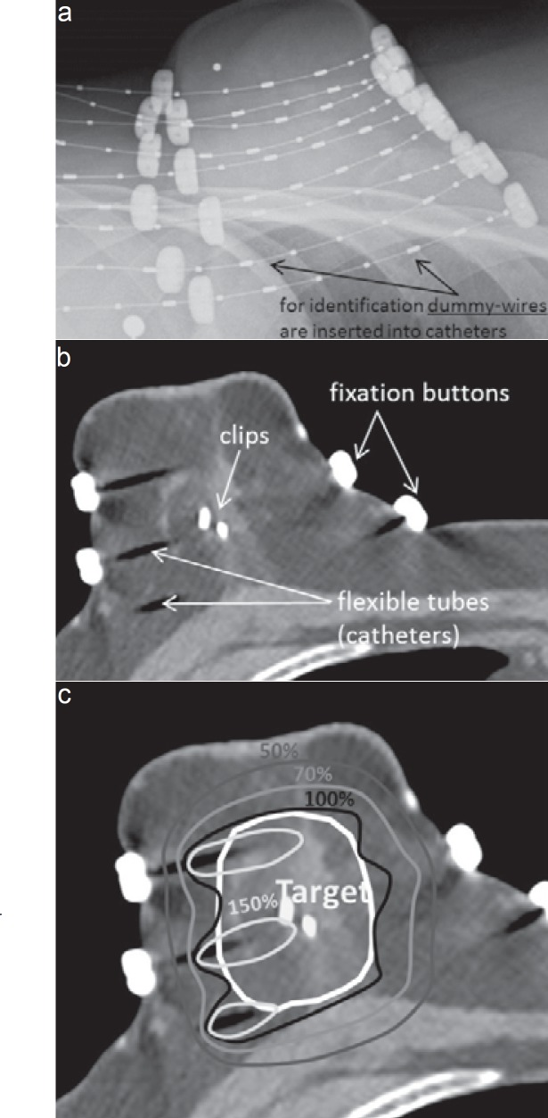

**Fig. 1**

Development from **a** X-ray-based catheter visualization to **b** computed tomography-based brachytherapy planning and **c** dose distribution in an APBI (accelerated partial breast irradiation) patient. [7]

Brachytherapy can be permanent or temporary. Permanent brachytherapy is when the radiation source will be resident inside the patient body throughout the lifetime, while for the temporary brachytherapy, the radioactive source will be removed through catheters as the reverse of implantation, after the whole period of treatment is completed. For the radiation source, the most popular choice is iodine-125, with its half-life of 60.2 days, so the time period for one treatment is not very long for a considerable effect of killing small-sized tumor. While for some permanent brachytherapy, strontium-90 might be an optimal option since it has a half-life of 28 years (so fewer times to professional cancer treatment agency to replace the source to maintain the efficiency). However, in the real-world practice, breast cancer female patients do not wish to cut off the whole tumor tissue or remove the breast for the sake of beauty or intention to feed their children, and thereby the temporary brachytherapy could be a better choice as permanent brachytherapy has uncertain effect on the milk, like radioactive to children, produced by mothers with breast cancer.

For any kinds of radiation source, the radiation dose is another factor to consider as radiation degrades radially as the separation between the source and tissues increases. The fall-off of dose can be calculated as inversely proportional to square of the distance to the source (Tenderup et al., 2016) [8]. Combining the idea of decreasing damage to the surrounding healthy tissues and the formula, it can be obtained that the best site for implantation of radiation source is the center of the tumor tissue. If it is not at the appropriate position, the decent radiotherapeutic effect will not be achieved. Furthermore, the tumor size and the bearable radiation to healthy tissues should also be considered as factors – the larger the tumor, the higher dose of radiation source is needed to have sufficient damage to the outer layer of cancer cells; while if too high dose of radiation source is used, the radiation beam to the surrounding healthy tissues may still remain at high energy level that may shoot their DNA causing cell death or mutations.

# Review of clinical data

Multi-catheter interstitial brachytherapy is the most common clinical type of brachytherapy in the treatment of breast cancer. ‘Multi-catheter’ means multiple sites (typically 10-20 sites) are chosen to plant the radioactive source to increase the efficiency to kill cancer cells and ensure the cancer cells at the edge of the tumor will receive sufficient radiation to cause damage to the DNA. And ‘interstitial’ means the radioactive sources will be planted in the gaps between the cancer cells.

In clinical treatment, there are generally three therapeutic dose options: High dose rate, pulsed dose rate and low dose rate. And the choose of dose rate is carefully considered which mainly depends on the pain to the patients, ages of patients and the efficiency to kill the cancer cells.

In table 1, all of three dose rates are included, their efficiency, safety and potential drawbacks are listed. Through the table, the ages of patients are mainly above 55; therefore, the results and following analyses are mainly related to the midlife patients.

The pain due to brachytherapy cannot be concluded as closely relating to the dose rate (the data about pain caused by LDR is missing); while the pain will be definitely decreased as the time passed (decreased about 3 times after 5 years).

The infection is highly related to the modernization of medical care, the three sets of data that have infection higher than 10% is mainly collected around 2004; with improvements in the medical treatment, the infection rate is much lower in the data collected around 2010s.

It is inevitable that the radiation will cause some fat necrosis, which means the healthy adipose tissues around the breast will be damaged. Up to 25% of the patients were diagnosed with fat necrosis when treat with high dose rate of brachytherapy. By comparing the median age of the patients, it can be assumed that fat necrosis is more commonly appeared in elder patients. However, with more precise data, the level of damage of fats is not extremely severe (mostly are around level 1 and 2 ----- which usually indicates the fragments of adipose tissues are discovered).

Another key factor about treating cancer successfully is whether the tumor has been fibrotic or not. Fibrotic tumor is usually more difficult to be cleaned up completely and cause trouble in the treatment. Through the data collected, about half of the patients will face the problem of fibrosis; however, the level of fibrosis is commonly low which is 1 or 2 that means only portal fibrosis has been appeared with the absence of septa. Without a doubt, the fibrosis will slower the process of treatment but a low leveled fibrosis will not affect the efficiency of brachytherapy a lot (as the local recurrence rate is still low, about 5%, even the fibrosis is quite common for breast cancer patients when they receiving brachytherapy).

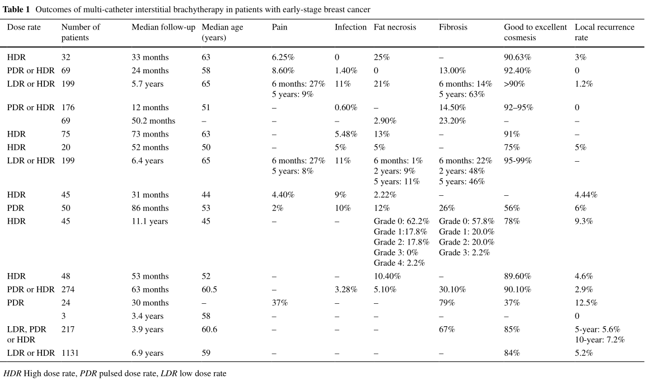**Table 1 [9]**

In table 2, the comparison between multi-catheter interstitial brachytherapy and whole-breast irradiation is shown.

The most important thing is the survival rate after the treatment, it determines the usefulness of the treatment. Comparing the sets of data, the survival rates of MIB and WBI are mainly above 90%; and one factor that needs to be noticed is the low survival rate (about 70% to 80%) mostly takes place in 65-year-old patient groups with a longer time period of follow-up, that indicates the elder patients have median-to-upper survival rate by either MIB or WBI.

The results of the two treatments have some differences. Firstly, the cosmetic results for MIB are mainly good (approximately 70%), while for the WBI, it can be seen that nearly of the patients get general or poor results. Additionally, the breast fibrosis is nearly absent in WBI but close to half of the patients receiving MIB were diagnosed as mild breast fibrosis. Another comparison takes place about fat necrosis, in average, less than 20% of the patients have the symptom of fat necrosis, and patients that receiving WBI have the lower possibility to face the problem; however, once the patients receiving WBI are diagnosed with fat necrosis, they have higher chance to be symptomatic; in contrast, the patients receiving MIB are commonly diagnosed as asymptomatic.

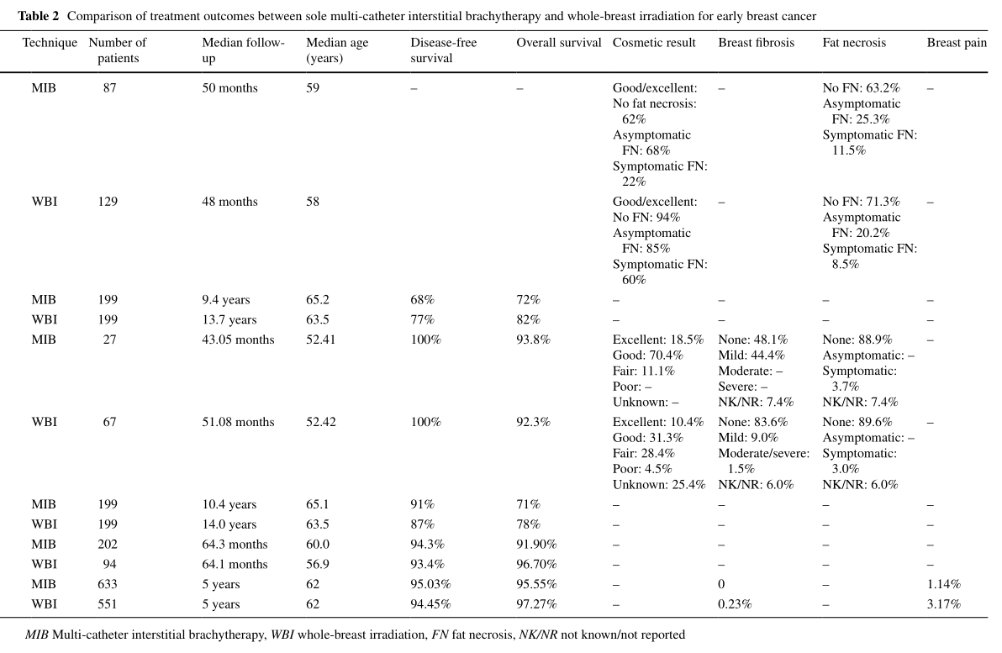

**Table 2 [9]**

Brachytherapy is a relatively new type of radiotherapy, comparing with the developed WBI, the damage to the surrounding might be slightly higher but the survival rate and recovery after the treatment undoubtedly have the potential to be better than traditional ways.

# Comparison with other treatments

Comparing with other types of treatment, like chemotherapy, the advantage of brachytherapy is remarkable because it only affects the surrounding area of the tumor tissues, and ensures the other parts of the body to be intact. Comparing with other forms of radiotherapy, since it emits radiation from the internal site of tumor, it minimizes the harm to the surrounding normal cells (as the high energy level radiation does not pass through the healthy tissues first) if the dose is controlled accurately and also maximizes the cancerous damage since it concentrates the therapeutic effect from the internal source. While the drawback is also inescapable, it is not feasible when the metastasis of cancer cells takes place as the cancer cells are distributed to other sites of the body which are difficult to locate and it is impossible to put radioactive sources all around patients’ bodies. Similar to the traditional forms of radiotherapy, it still has the damage to the surrounding cells and might affect the life quality of the patients. In addition, very accurate position of the tumor needs improvement on the quality of implantation of radiation source through costly high-technology modeling system.

# Conclusion

There are three main issues that need to be considered or researched in the future. Firstly, radiation dose should be carefully controlled that the damage to the surrounding healthy tissues is minimized while the effect to kill cancer cells are ensured. Additionally, the safety in the long term should be considered in the future, because during implantation, it is inescapable that the medical staff will expose to the radioactive source and after the implantation, there is potential possibility that the radioactive ray will pass to the patients’ family members; so further research should take place for the safety of people other than patients in longer term. Last but not the least, it is undoubted that the damage to the tumor is maximized at first, but in longer term, the energy released from the radioactive source will reasonably decrease as its activity is lower. So, its efficiency to kill cancer cells in long term is still lack of date, and further research should be taken place.

# Reference

1. Bray F., Ferlay J., Soerjomataram I., Siegel R.L., Torre L.A., Jemal A. (2018) Global cancer statistics 2018: GLOBOCAN estimates of incidence and mortality worldwide for 36 cancers in 185 countries, CA: A Cancer Journal for Clinicians, 68(6), 394-424.
2. Maughan K.L., Lutterbie M.A., Ham P.S. (2010) Treatment of breast cancer, Am Fam Physician, 81(11), 1339-1346.
3. Gardner S. J., Kim J., Chetty I. J. (2019) Modern Radiation Therapy Planning and Delivery. *Hematology/oncology clinics of North America*, *33*(6), 947–962.
4. Marwaha G., Macklis R., Singh A. D., Wilkinson A. (2013) Brachytherapy, Developments in ophthalmology, 52, 29–35.

5, 9. Deng X., Wu H., Gao F., Su,Y., Li Q., Liu S., Cai, J. (2017) Brachytherapy in the treatment of breast cancer, International journal of clinical oncology, 22(4), 641–650.

6, 8. Tanderup K., Ménard C., Polgar C., Lindegaard J. C., Kirisits C., Pötter R. (2017) Advancements in brachytherapy, Advanced drug delivery reviews, 109, 15–25.

1. Kauer-Dorner D., Berger D. (2018) The Role of Brachytherapy in the Treatment of Breast Cancer. *Breast care (Basel, Switzerland)*, *13*(3), 157–161.